Project Report for Computer Networks (CS1602)

**Networking in University**

Submitted to Manipal University, Jaipur

Towards the partial fulfillment for the Award of the Degree of

**BACHELORS OF TECHNOLOGY**

In Information Technology

2019-2020

By

Diksha Phuloria 179302047

Greeshma Maske 179302053



Under the Guidance of

Dr. Narendra Singh Yadav

(May-2020)

**Department of Information Technology**

**School of Computing and Information Technology**

**Manipal University Jaipur**

**Jaipur, Rajasthan**

CERTIFICATE

Date: 21/05/2020

This is to certify that the project work entitled “Networking in University” submitted by Diksha Phuloria (179302047) and Greeshma Maske (179302053) in fulfillment for the requirements of the award of Bachelor of Technology Degree in Information Technology at Manipal University Jaipur is an authentic work carried out by them under my supervision and guidance. To the best of my knowledge, the matter embodied in the project has not been submitted to any other University / Institute for the award of any Degree.

Dr. Narendra Singh Yadav Dr. Pankaj Vyas

Project Guide HOD

Department of IT Department of IT

Manipal University Jaipur Manipal University Jaipur

ABSTRACT

Computer networks have a significant impact on the working of an organization. Universities depend on the proper functioning and analysis of their networks for education, administration, communication, e-library, automation, etc. An efficient network is essential to facilitate the systematic and cost-efficient transfer of information in an organization in the form of messages, files, and resources. The project provides insights into various concepts such as topology design, IP address configuration, and how to send information in the form of packets to the wireless networks of different areas of a University.

The aim of this project is to design the topology of the university network using the software Cisco Packet Tracer with the implementation of wireless networking systems. This university network consists of the following devices:

1) Router (1941)

2) Switches (2960-24TT)

3) Email server

4) DNS server

5) WEB server (HTTP)

6) Wireless Device (Access Point)

7) PCs

8) Laptops

9) Smartphones

The design includes the following parts of the University:

Hostel Blocks: Girls Block and Boys Block

Academic Blocks: AB1 and AB2

Dome Building and Library

IT Consulting

TABLE OF CONTENTS

|  |  |  |
| --- | --- | --- |
| 1. | Cover Page | 1 |
| 2. | Certificate | 2 |
| 3. | Abstract | 3 |
| 4. | Table of Contents | 4 |
| 5. | Chapter 1: Introduction | 5 |
| 6. | Chapter 2: Literature Review | 6 |
| 7. | Chapter 3: Work Done | 10 |
| 8. | Chapter 4: Results and Discussion | 25 |
| 9. | Chapter 5: Conclusions and Future Work | 29 |
| 10. | References | 30 |

CHAPTER 1

INTRODUCTION

* **Motivation**

The word “digital” is very significant in today’s world, with an increase in the development of technology the entire world is moving towards the digital era. The educational institution plays an important role in this digitalization, hence the campus should adapt to digital means of networking as well and become a “digital campus”. Going wireless plays an important role in this digitalization. The wireless network makes the connection easy with a reduction in the use of wires or cables. A wired connection makes it difficult to keep track of all the devices and to manage the cable connection, which is not only chaotic but also challenging to handle.

Campus networking via wireless connection becomes an important part of campus life and provides the main way for teachers and students to access educational resources, which gives an important platform to exchange information. As laptops and intelligent terminals are widely used, demand for access to information anytime and anywhere has become more and more urgent, but traditional cable networks cannot meet this requirement. Then wireless network construction becomes necessary and essential. The wireless network is one of the important components of a digital campus and wisdom campus. It provides an efficient way to explore the internet with a mobile terminal for teachers and students regardless of cables and places. This is an important mark of the modern campus as a supplement of a cable network. With the development of network and communication technology, cable networks on a university campus bring much convenience for teaching and research work. But for mobility and flexibility, it has obvious shortcomings. A wireless network can overcome these drawbacks and has been applied to the university campus.

* **Project Statement**

In this mini-project, we defined a simulation of campus networks based on wireless networking. The network is divided into two sets: one for the campus area and the other for the hostel area.

The major aim of this project is to show the wireless connectivity that is used in universities to make the network efficient and mobile at the same time. Mobility is the major concentration of this project. In order to provide equal functionality to all the users (college staff and students), we have added DNS, Email, and HTTP servers for the maximum utilization of resources.

Hence the campus network provides different services such as connecting the user to the internet, data sharing among users (students, teachers, and different university members), accessing different web services for different functionalities, so it needs wireless networking for smooth processing.

CHAPTER 2

LITERATURE REVIEW

* What is Packet Tracer? [1]

Packet Tracer is a cross-platform visual simulation tool designed by Cisco Systems that allows users to create network topologies and imitate modern computer networks. The software allows users to simulate the configuration of Cisco routers and switches using a simulated command-line interface. Packet Tracer makes use of a drag-and-drop user interface, allowing users to add and remove simulated network devices as they see fit. The software is mainly focused on Certified Cisco Network Associate Academy students as an educational tool for helping them learn fundamental CCNA concepts. Previously students enrolled in a CCNA Academy program could freely download and use the tool free of charge for educational use.

* Router

A router is a device like a switch that routes data packets based on their IP addresses. The router is mainly a Network Layer device. Routers normally connect LANs and WANs together and have a dynamically updating routing table based on which they make decisions on routing the data packets. Router divides broadcast domains of hosts connected through it.

* Switch

A network switch (also called switching hub, bridging hub, officially MAC bridge is networking hardware that connects devices on a computer network by using packet switching to receive and forward data to the destination device. A network switch is a multiport network bridge that uses MAC addresses to forward data at the data link layer (layer 2) of the OSI model. Some switches can also forward data at the network layer (layer 3) by additionally incorporating routing functionality. Such switches are commonly known as layer-3 switches or multilayer switches.

* Network Packet

A network packet is a formatted unit of data carried by a packet-switched network. A packet consists of control information and user data, which is also known as the payload.

* Server [2]

A server is a computer or system that provides resources, data, services, or programs to other computers, known as clients, over a network. In theory, whenever computers share resources with client machines they are considered servers. There are many types of servers, including web servers, mail servers, and virtual servers.

Many networks contain one or more of the common servers. The servers used in our project are as follows:

* DNS Server

DNS stands for Domain Name System servers which are application servers that provide a human-friendly naming method to the user computers in order to make IP addresses readable by users. The DNS system is a widely distributed database of names and other DNS servers, each of which can be used to request an otherwise unknown computer name. When a user needs the address of a system, it sends a DNS request with the name of the desired resource to a DNS server. The DNS server responds with the necessary IP address from its table of names.

* WEB Server

One of the widely used servers in today’s market is a web server. A web server is a special kind of application server that hosts programs and data requested by users across the Internet or an intranet. Web servers respond to requests from browsers running on client computers for web pages, or other web-based services.

* EMAIL Server

An e-mail server is a server that handles and delivers e-mail over a network, using standard email protocols. For example, the SMTP protocol sends messages and handles outgoing mail requests. The POP3 protocol receives messages and is used to process incoming mail. When you log on to a mail server using a webmail interface or email client, these protocols handle all the connections behind the scenes.

* Wireless Network

A wireless network broadcasts an access signal to the workstations or PCs. This enables mobility among laptops, tablets, and PCs from room to room while maintaining a firm network connection continuously. A wireless network also presents additional security requirements.

* Ethernet

This is the backbone of our network. It consists of the cabling and is typically able to

transfer data at a rate of 100mb/s. It is a system for connecting a number of computer systems to form a local area network, with protocols to control the passing of information and to avoid simultaneous transmission by two or more systems. Among the different types of ethernet, we have used Gigabit Ethernet, which is a type of Ethernet network capable of transferring data at a rate of 1000 Mbps and fast Ethernet is a type of Ethernet network that can transfer data at a rate of 100 Mbps.

* Computing Device

Computing devices are the electronic devices that take user inputs, process the inputs, and then provide us with the end results. These devices may be Smartphones, PC Desktops, Laptops, printer, and many more.

* Internet Protocol

Internet Protocol (IP) is one of the fundamental protocols that allow the internet to work. IP addresses are a unique set of numbers on each network and they allow machines to address each other across a network. It is implemented on the internet layer in the IP/TCP model.

* SSH Protocol[3]

Secure Shell enables a user to access a remote device and manage it remotely. However, with SSH, all data transmitted over a network (including usernames and passwords) isencrypted and secure from eavesdropping.

SSH is aclient-server protocol, with an SSH client and an SSH server. The client machine (such as a PC) establishes a connection to an SSH server running on a remote device (such as a router). Once the connection has been established, a network admin can execute commands on the remote device.

* Benefits of wireless networking over wired networking[5]

To better understand the wide usage of wireless networking in today’s world, is to start with the benefits it has over traditional wired networking is crucial for our project implementation. Some major aspects have been stated below that show the various advantages of a wireless network over wired ones.

1. Mobility

One of the major advantages of wireless is mobility. Users have the freedom to move within the area of the network with their computing devices staying connected to a network without being concerned about the cable connection.

1. Less Hassle

The wireless network helps in the reduction of large amounts of cables or wires which becomes chaotic and difficult to maintain, it makes the connection hassle-free.

1. Accessibility

Provide network access across your organization, even in areas that have been challenging to reach with the wired network, so your entire team can stay in touch.

1. Expandability

The wireless network helps in the expansion of the network to a wide range by adding multiple new users and locations without additional need to run cables and wires.

1. Guest Access

Offer secure network access to guest users, including customers and business partners, while keeping your network resources protected.

With lots of advantages, there come disadvantages as well, like security issues which can be resolved using strict protection passwords. Also, the Speed of wireless networks is considered to be slow and having low bandwidth when compared to the direct cable connection networks.

* Simulation Environment

The simulations of our network topology can be easily achieved using cisco packet tracer. Using a simulation mode, you can see packets flowing from one node to another and can also click on a packet to see detailed information about the OSI layers of the networking. Packet Tracer offers a huge platform to combine realistic simulation and visualize them simultaneously. Cisco Packet Tracer makes learning and teaching significantly easier by supporting multi-user collaboration and by providing a realistic simulation environment for experimenting with projects.

CHAPTER 3

WORK DONE

In order to make our project understandable, we have divided the content into steps. They are as follows:

1. **Software and hardware requirements**

Before heading towards the implementation we need to make sure of the following requirements.

* A proper workstation (any mid-high range laptop will suffice).
* Packet Tracer by Cisco
* 8 GB RAM.
* Any 10,000+ Average CPU Mark scored processor.
* 16 GB of dedicated hard disk space.
* USB 3.0+ port.

1. **Brief knowledge about our approach**

The proposed wireless network is implemented for a university campus. We have made a virtual visualization of the network using the Cisco Packet tracer which provides a huge platform for users to test their projects using simulation tools. A Wireless network in an educational campus makes it easier for teachers and students to access educational resources, by enabling an important platform to exchange information.

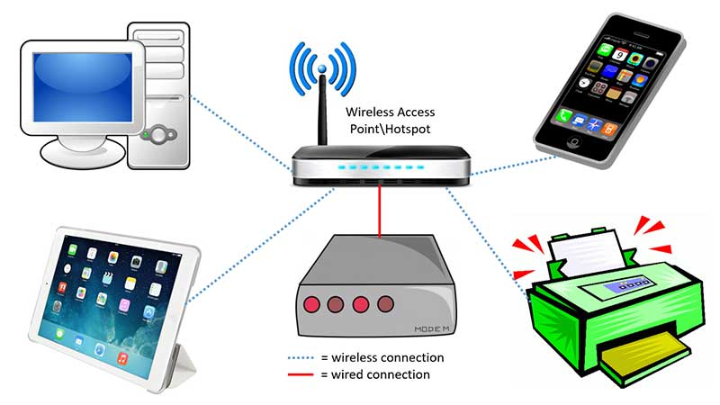

Figure 1: Shows the wireless connection access by various tool

1. **Network Requirements**

Manipal University Jaipur outline is considered for this wireless university network.

The network is divided into 2 areas :

1. Campus Area

The Campus area is further divided into various accessing points like Dome building, Library, Academic Blocks (AB1 and AB2), Server Center, and IT consulting.

1. Hostel Area

The Hostel area is further divided into Boys blocks and Girls blocks respectively.

Figure 2:Basic layout of our wireless access points in University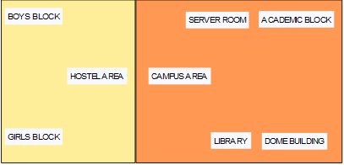

Devices Used In The Network

|  |  |
| --- | --- |
| Devices | Quantity |
| 1) Router (1941) | 3 |
| 2) Switches (2960-24TT) | 3 |
| 3) EMAIL server | 1 |
| 4) DNS server | 1 |
| 5) WEB server (HTTP) | 1 |
| 6) Wireless Device (Access Point) | 7 |
| 7) PCs | 12 |
| 8) Laptops | 10 |
| 9) Smartphones | 2 |

Figure 3: Devices used in the network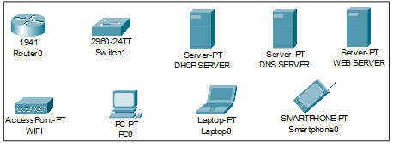

1. **Implementation and Flow Diagram**

* To design the wireless network of the university we initially started by placing the core devices into the frame as mentioned in the layout.
* Firstly, we placed the **main router** at the center of the university outline, which was further connected to the **server switch** using the gigabit ethernet port with copper straight-through cable and sub routers (**campus router and hostel router**) using the serial port with serial DCE cable at the hostel area and campus area respectively.
* The server switch was further connected to the **EMAIL, DNS, and WEB** servers respectively.
* Campus router was connected to the campus switch which was further connected with wireless access points of the academic block (**AB1 and AB2**), **dome building**, **library,** and **IT consulting.**
* The wireless access points were then connected to computing devices (PCs, laptops, and smartphones).
* Similarly, the hostel router was connected to the hostel switch which was further connected with the wireless access point of boys block and girls block.
* The wireless access points were then connected to the computing devices (PCs, laptops, and smartphones), every area has a dedicated access point which can only be connected with the help of a password.
* All these connections are made through ethernet ports (gigabit ethernet and fast ethernet) using copper straight-through cables.

This is the flow diagram for a better understanding of the steps mentioned above.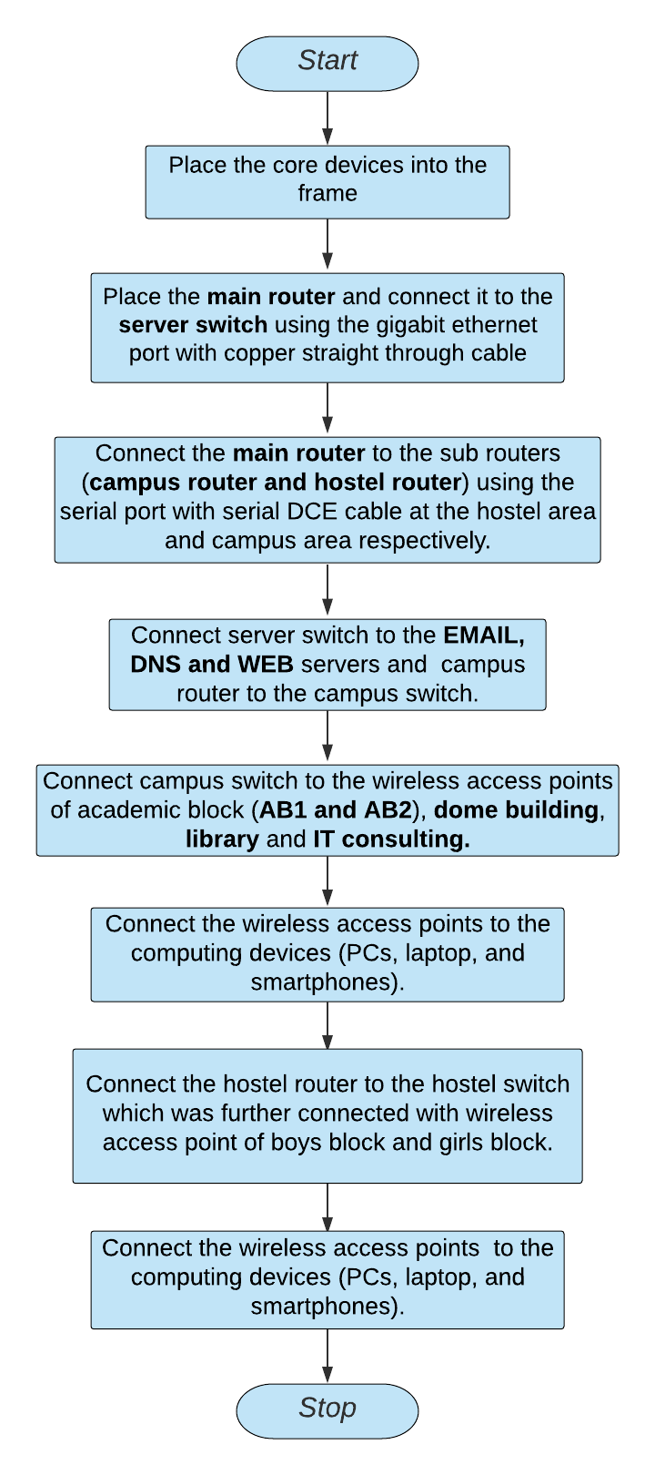

1. **Configuring IP Addresses**

We have attached the screenshots of all the IP configuration below:

* Main Router configuration

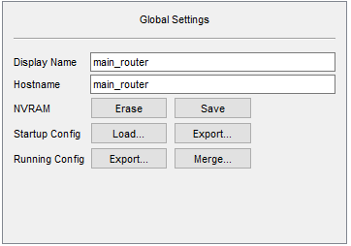

GigabitEthernet0/1

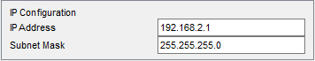

Serial0/1/0

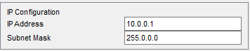

Serial0/1/1

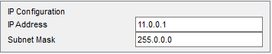

RIP

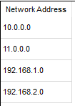

* DNS SERVER

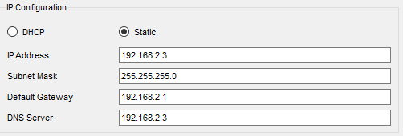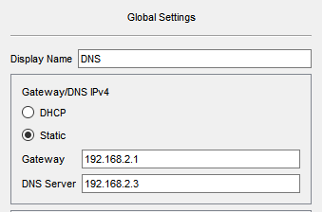

* WEB SERVER

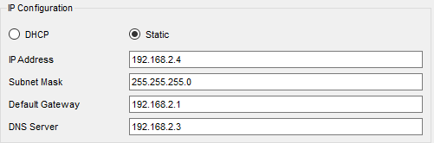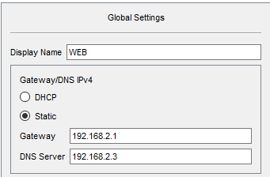

* EMAIL SERVER

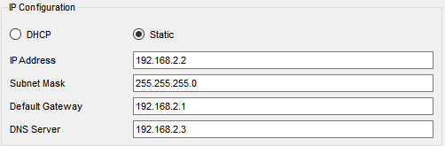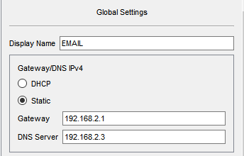

* COLLEGE ROUTER

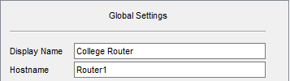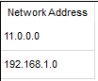

GigabitEthernet0/0

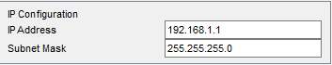

Serial0/1/0

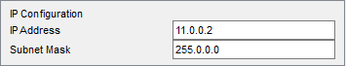

* ACADEMIC BLOCK 1

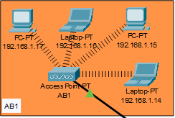

IP Address are as follows

192.168.1.14- Laptop

192.168.1.15- PC

192.168.1.16- Laptop

192.168.1.17- PC

Subnet Mask- 255.255.255.0

Default Gateway- 192.168.1.1

DNS Server- 192.168.2.3

* ACADEMIC BLOCK 2

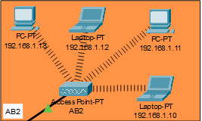

IP Address are as follows

192.168.1.10- Laptop

192.168.1.11- PC

192.168.1.12- Laptop

192.168.1.13- PC

Subnet Mask- 255.255.255.0

Default Gateway- 192.168.1.1

DNS Server- 192.168.2.3

* DOME BUILDING

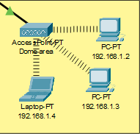

IP Addresses are as follows

192.168.1.2- PC

192.168.1.3- PC

192.168.1.4- Laptop

Subnet Mask- 255.255.255.0

Default Gateway- 192.168.1.1

DNS Server- 192.168.2.3

* LIBRARY

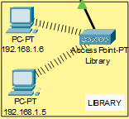

IP Addresses are as follows

192.168.1.5- PC

192.168.1.6- PC

Subnet Mask- 255.255.255.0

Default Gateway- 192.168.1.1

DNS Server- 192.168.2.3

* IT Consulting

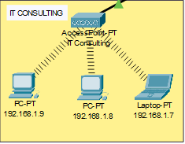

IP Addresses are as follows

192.168.1.7- Laptop

192.168.1.8- PC

192.168.1.9- PC

Subnet Mask- 255.255.255.0

Default Gateway- 192.168.1.1

DNS Server- 192.168.2.3

* HOSTEL ROUTER

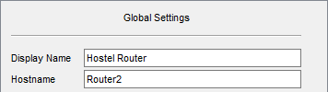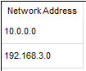

GigabitEthernet0/0

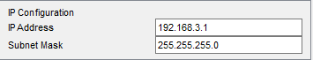

Serial0/1/0

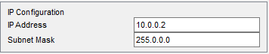

* Boys Block

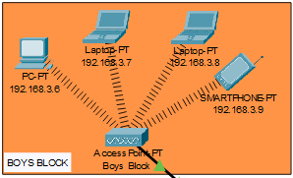

IP Addresses are as follows

192.168.3.6- PC

192.168.3.7-Laptop

192.168.3.8- PC

192.168.3.9- Smartphone

Subnet Mask- 255.255.255.0

Default Gateway- 192.168.3.1

DNS Server- 192.168.2.3

* Girls Block

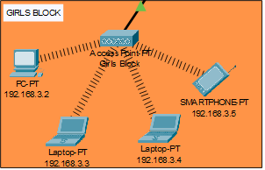

IP Addresses are as follows

192.168.3.2- PC

192.168.3.3-Laptop

192.168.3.4- PC

192.168.3.5- Smartphone

Subnet Mask- 255.255.255.0

Default Gateway- 192.168.3.1

DNS Server- 192.168.2.3

* WIRELESS ACCESS POINT

|  |  |
| --- | --- |
| SSID | Password |
| 1)muj_dome | 1234567890 |
| 2)muj_library | 1234567890 |
| 3)muj_ITC | 1234567890 |
| 4)muj_AB1 | 1234567890 |
| 5)muj_AB2 | 1234567890 |
| 6)muj_boys | 1234567890 |
| 7)muj_girls | 1234567890 |

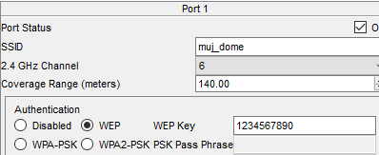

1. **Securing the network**

Passwords are used in accessing the router and all the wireless networks (mentioned in step 5 wireless access point) to make the access limited to University authorized users only.

Routers are also secured with ssh (Secure Shell). Routers and their assigned passwords are mentioned below:

|  |  |
| --- | --- |
| Router Name | Passwords |
| 1)main_router | Console password: cisco  ssh password: admin |
| 2)Router1(College Router) | Console password:muj@123  ssh password: admin |
| 3)Router2(Hostel Router) | Console password:muj@123  ssh password: admin |

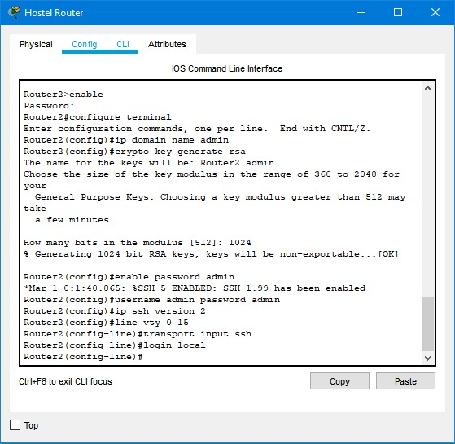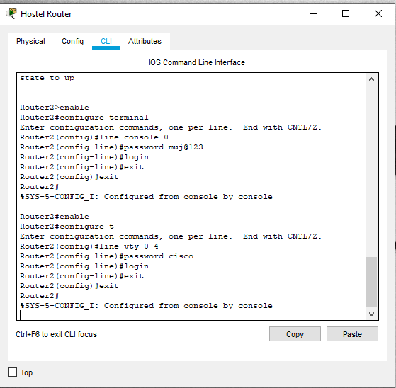

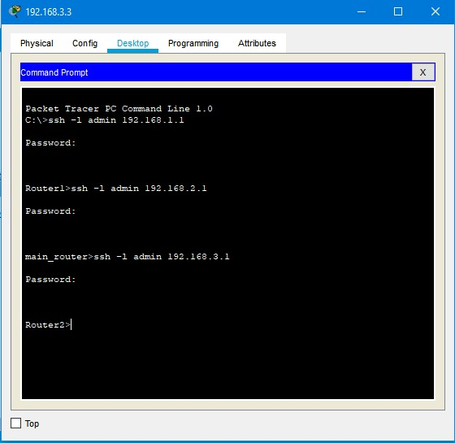

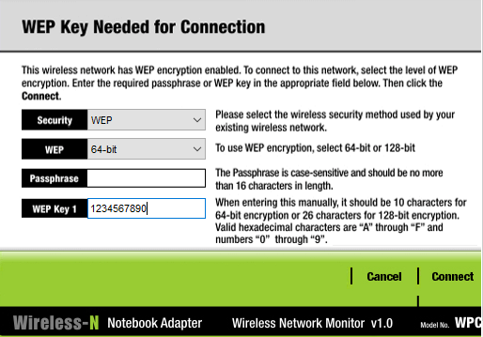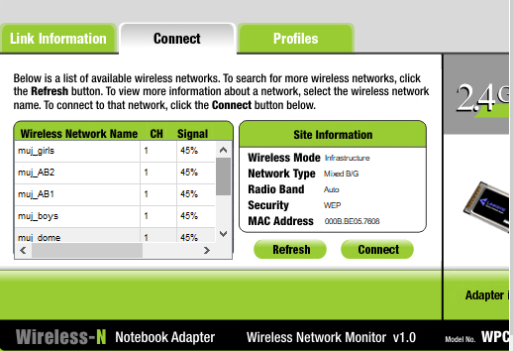

**Connectivity of wireless network on computing devices**

CHAPTER 4

RESULT & DISCUSSION

Finally, we have combined all the steps as mentioned in chapter 3 (work done) and implemented the desired wireless network for University. We have the complete network providing various facilities to the teaching staff, non-teaching staff, and students.

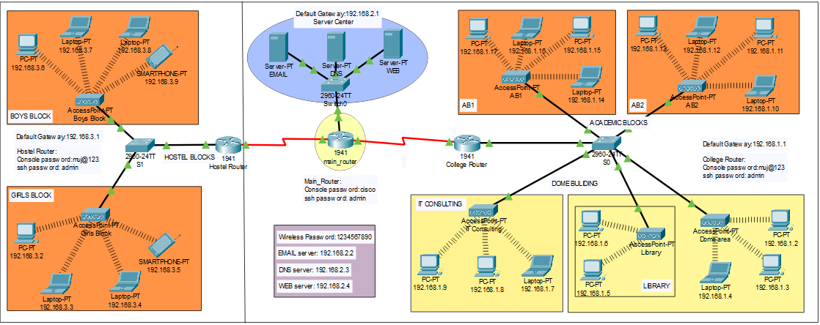

The complete diagram of the University Area Network Scenario created in Packet Tracer environment

* Final Simulation

In Simulation Mode, you can watch your network run at a slower pace, observing the paths that packets take and inspecting them in detail. The proposed architecture, when simulated on Cisco Packet Tracer, produced results which are demonstrated as follows:

Final simulation for the network system to check all the connections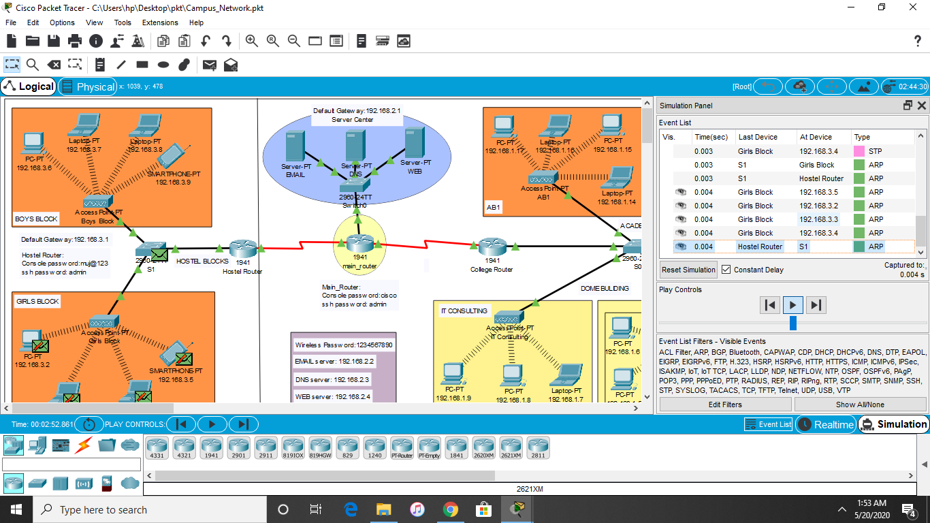

* Ping Test: Network connectivity and communication can be tested using the ping command, followed by the domain name or the IP address of the device (equipment) whose connectivity one wishes to verify.

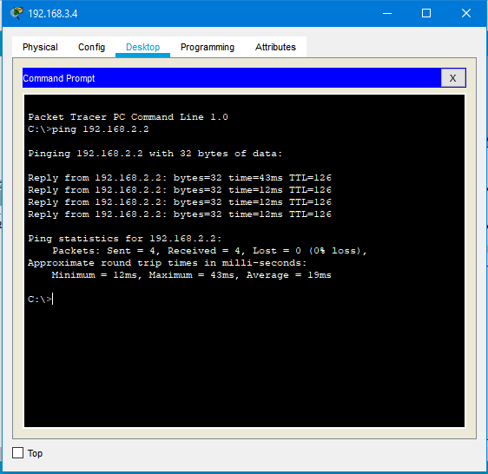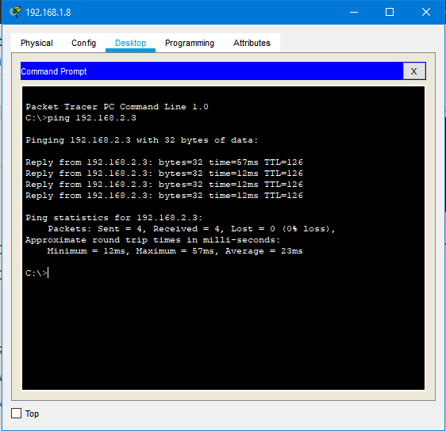

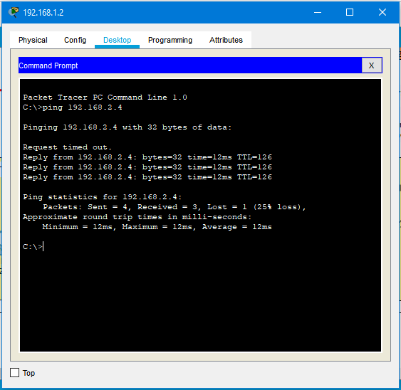



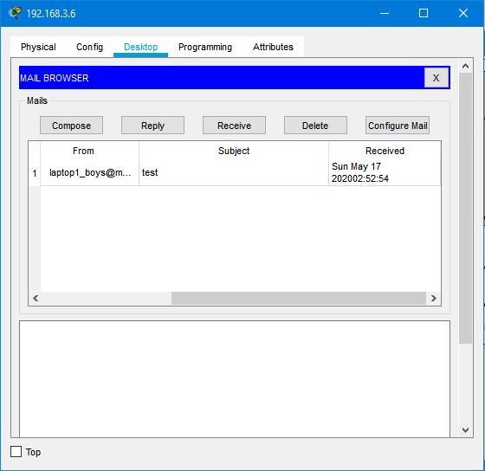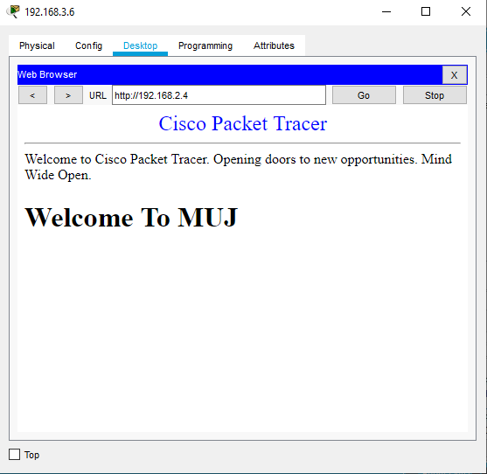





CHAPTER 5

CONCLUSION AND FUTURE WORK

* Conclusion

We started our discussion with the word “digitalization” and in order to achieve it, we aimed to start with an educational institute, and finally, we designed a network for a University, which is wireless. As we mentioned, mobility and efficiency are the key aspects of wireless networks, which were our main goal, and hence, we decided to shift to a wireless network instead of a wired one, making our network clean and less chaotic.

In this project, we designed a University Network using Cisco Packet Tracer that uses a networking topology implemented using servers, routers, switches, and end devices in a multiple area networks. We have covered all the necessary features that are required for a network to function properly. We have included a DNS server and a web server for establishing a smooth communication system between different areas of our network and specifically for the communication between students and teachers. We have included an email server to facilitate intra university communication through emails within the domain. We have used console passwords and ssh protocol to ensure a safe and secure transfer of data.

* Future Work

The configuration and specifications are for the initial prototype and can further be developed and additional functionality can be added to increase support and coverage of our existing network.

REFERENCES

[1]<https://en.wikipedia.org/wiki/Packet_Tracer>

[2]<https://www.paessler.com/it-explained/server>

[3]<https://computernetworking747640215.wordpress.com/2018/07/05/secure-shell-ssh-configuration-on-a-switch-and-router-in-packet-tracer/>

[4]<http://router.over-blog.com/article-how-to-configure-cisco-router-password-106850439.html>

[5]<https://www.cognoscape.com/benefits-going-wireless/>